ASSIGNMENT-12.1
Name: I.Harshith
HT. No: 2303A51624
Batch: 08
Lab 12: Algorithms with AI Assistance – Sorting, Searching,
and Optimizing Algorithms
Task Description #1 (Sorting – Merge Sort Implementation)
• Task: Use AI to generate a Python program that implements
the Merge Sort algorithm.
• Instructions:
o Prompt AI to create a function merge_sort(arr) that
sorts a list in ascending order.
o Ask AI to include time complexity and space
complexity in the function docstring.
o Verify the generated code with test cases.
• Expected Output:
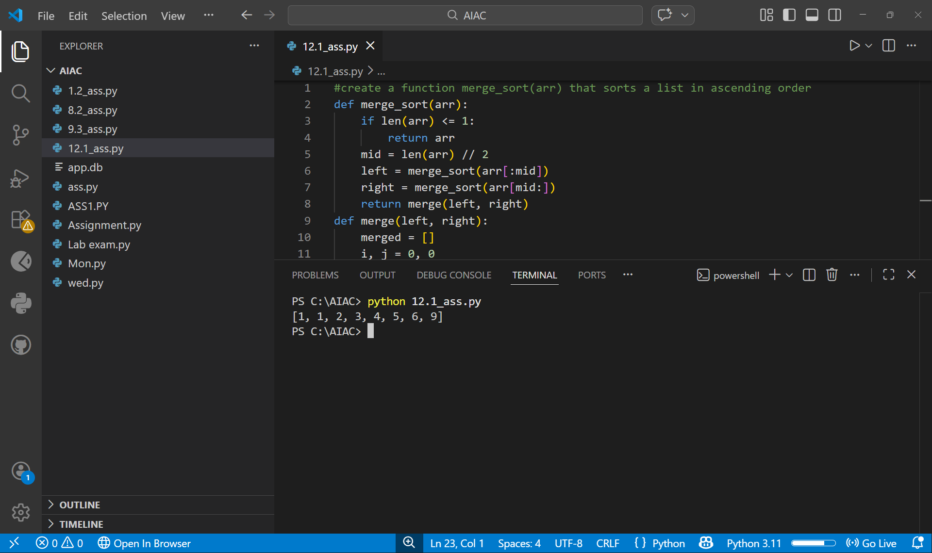
Task Description #2 (Searching – Binary Search with AI
Optimization)
• Task: Use AI to create a binary search function that finds a
target element in a sorted list.
• Instructions:
o Prompt AI to create a function binary_search(arr,
target) returning the index of the target or -1 if not
found.
o Include docstrings explaining best, average, and
worst-case complexities.
o Test with various inputs.
• Expected Output:
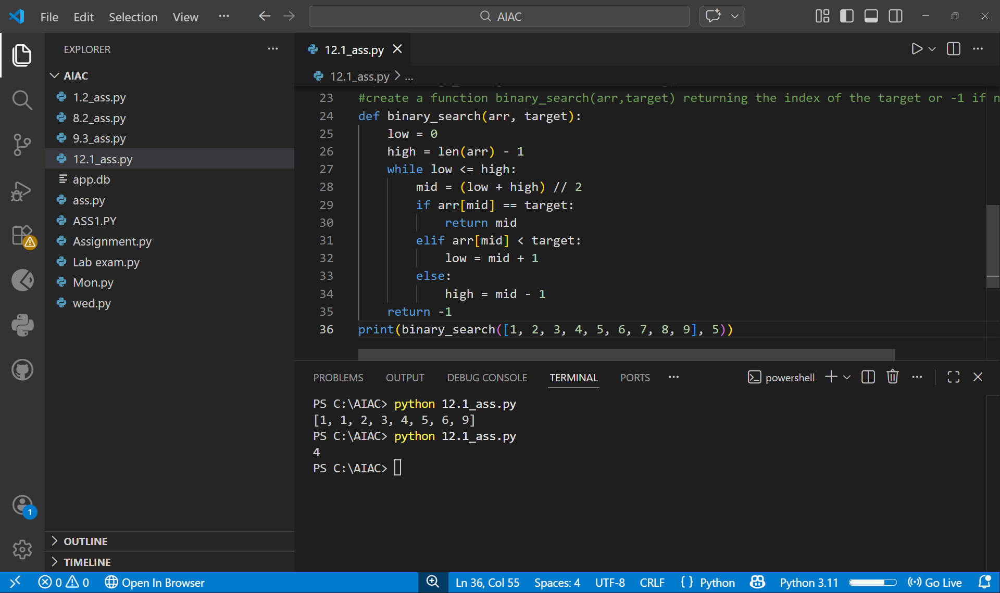Task Description #3 (Real-Time Application – Inventory
Management System)
• Scenario: A retail store’s inventory system contains
thousands of products, each with attributes like product ID,
name, price, and stock quantity. Store staff need to:
1. Quickly search for a product by ID or name.
2. Sort products by price or quantity for stock analysis.
• Task:
o Use AI to suggest the most efficient search and sort
algorithms for this use case.
o Implement the recommended algorithms in Python.
o Justify the choice based on dataset size, update
frequency, and performance requirements.
• Expected Output:
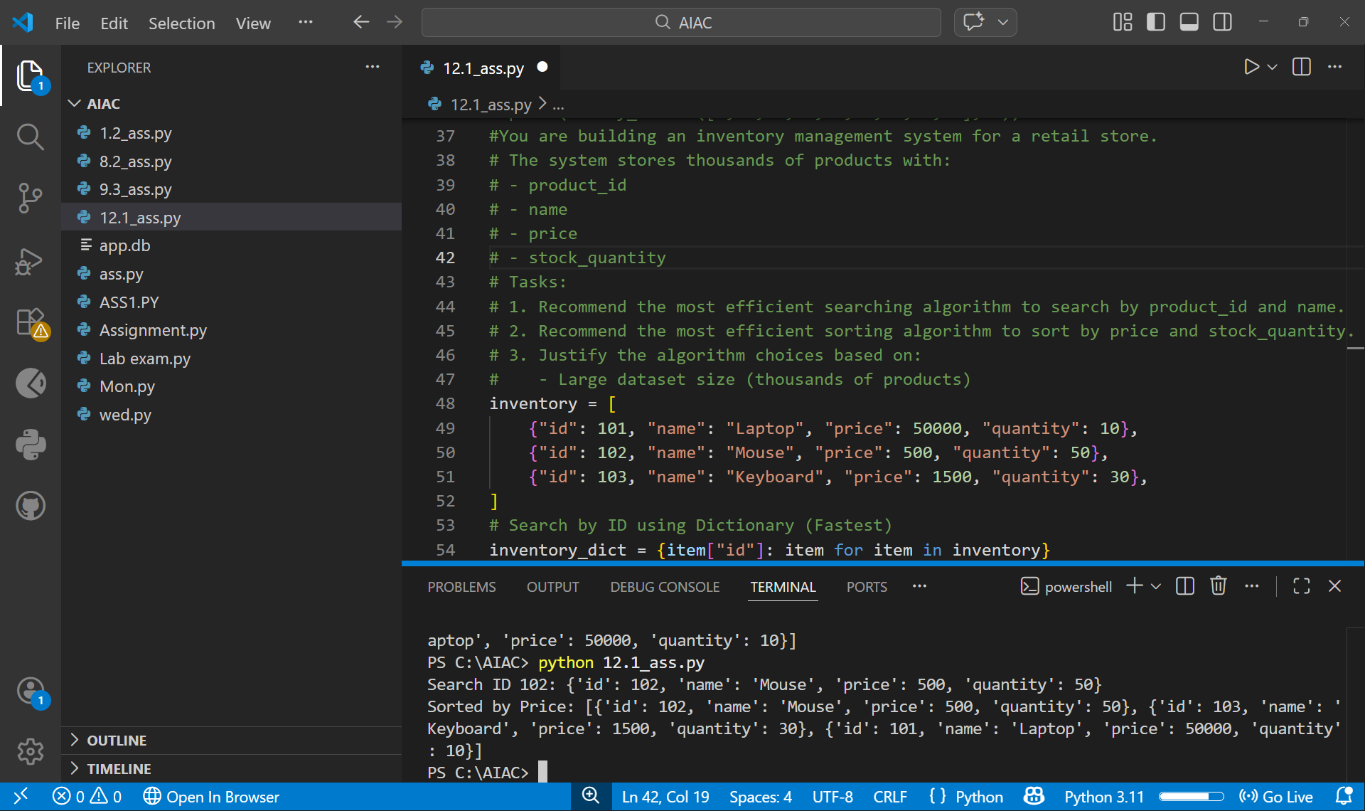
Task description #4: Smart Hospital Patient Management
System
A hospital maintains records of thousands of patients with details
such as patient ID, name, severity level, admission date, and bill
amount. Doctors and staff need to:
1. Quickly search patient records using patient ID or name.
2. Sort patients based on severity level or bill amount for
prioritization and billing.
Student Task
• Use AI to recommend suitable searching and sorting
algorithms.
• Justify the selected algorithms in terms of efficiency and
suitability.
• Implement the recommended algorithms in Python.
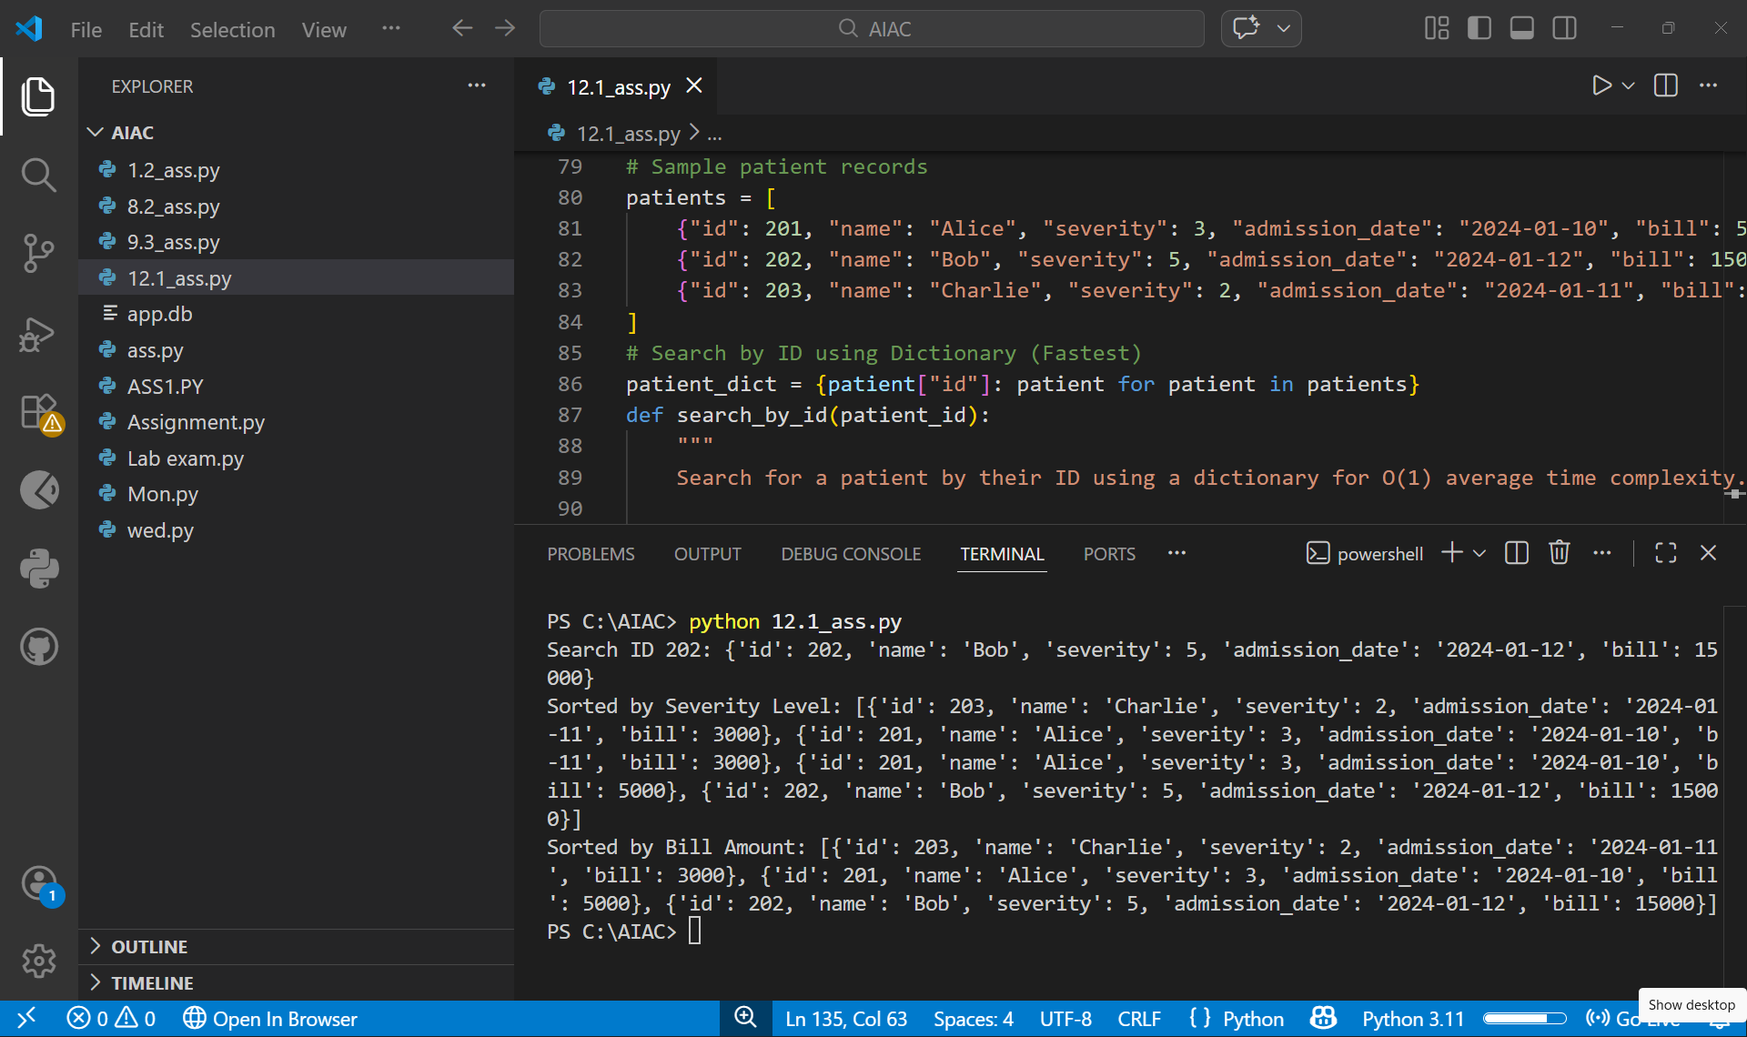
Task Description #5: University Examination Result Processing
System
A university processes examination results for thousands of students
containing roll number, name, subject, and marks. The system must:
1. Search student results using roll number.
2. Sort students based on marks to generate rank lists.
Student Task
• Identify efficient searching and sorting algorithms using AI
assistance.
• Justify the choice of algorithms.
• Implement the algorithms in Python.
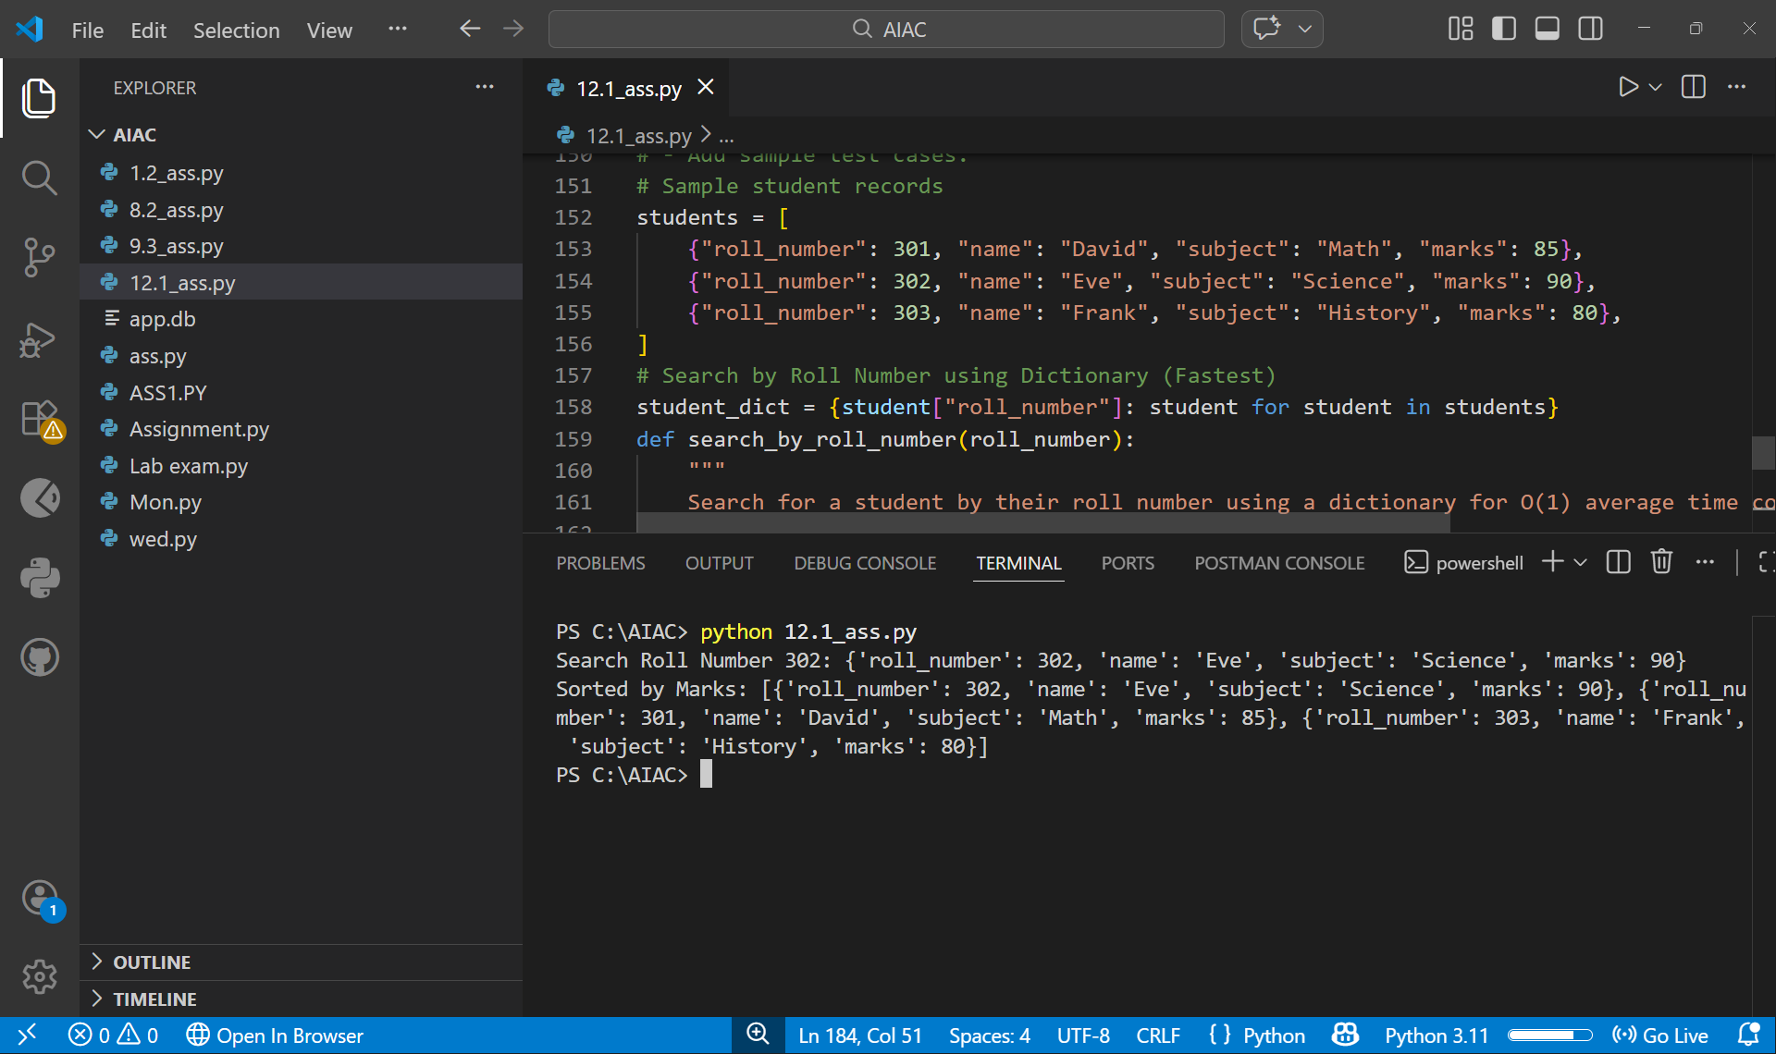
Task Description #6: Online Food Delivery Platform
An online food delivery application stores thousands of orders with
order ID, restaurant name, delivery time, price, and order status. The
platform needs to:
1. Quickly find an order using order ID.
2. Sort orders based on delivery time or price.
Student Task
• Use AI to suggest optimized algorithms.
• Justify the algorithm selection.
• Implement searching and sorting modules in Python.
